

**PROJECT DOCUMENTATION**

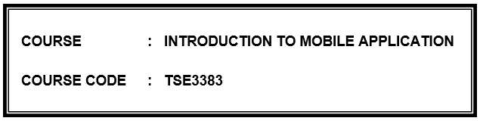

NAME : MUHAMMAD BIN MAZLAN

ID NO : AM1905005918

SECTION : SECTION 1

LECTURER : ANIS JUANITA BINTI MOHD ZAINUDIN

KOLEJ UNIVERSITY POLY-TECH MARA

1120

1. **PROJECT DESCRIPTION**

Mathematic for Kids is an application that is provided to childrens at Tadika Islam U-pintar for learning about math. This application is an educational application developed for children that provides materials to help children learn about math easier. The type of system that is used to make this application is construct 2. Construct 2 is a web-based 2D game creation tool that doesn’t require much knowledge of programming languages. It uses a paneled interface reminiscent of older Windows programs with the main panel in the middle containing a tabbed area that shows off the game's playing area. Moreover, the different game screens are kept in separate tabs in the main panel in the middle. Other tabs hold all the scripts and programming for all the events or behaviors for the screens and their objects, with one tab for each game screen.

The reason this application is needed because after the children returned to their home, they might forget a little about what they have learned at kindergarten because the knowledge that is not practiced every day not to mention the thing that they don’t understand or like, for example like mathematics. As stated on Prodigy, kids nowadays are less good in math because it’s a cumulative subject and it builds upon itself year after year, so learning and understanding the basics is a must. If a child falls behind in one due to a lack of understanding, moving on to more advanced topics will remain a challenge. Therefore, to avoid the children from lack of understanding, a better platform of learning math application is needed to gain the interest of children in mathematics so they can learn anywhere anytime even at home. Moreover, as technology becomes more a part of our day-to-day lives, some are worried that it is stunting the education of children by taking away time from activities like reading. A startling discovery from the London-based National Literacy Trust finds that children are more likely these days to own a cell phone than a book. Thus, to take this threat to be an advantage so that they can learn maths, this project application is needed. Throughout extensive research, it has been proven that most kindergarten nowadays must have an mobile application or suggestion of mobile application to let the children learn even at home.

1. **INTERFACE DESIGN**
   1. Output / screen design

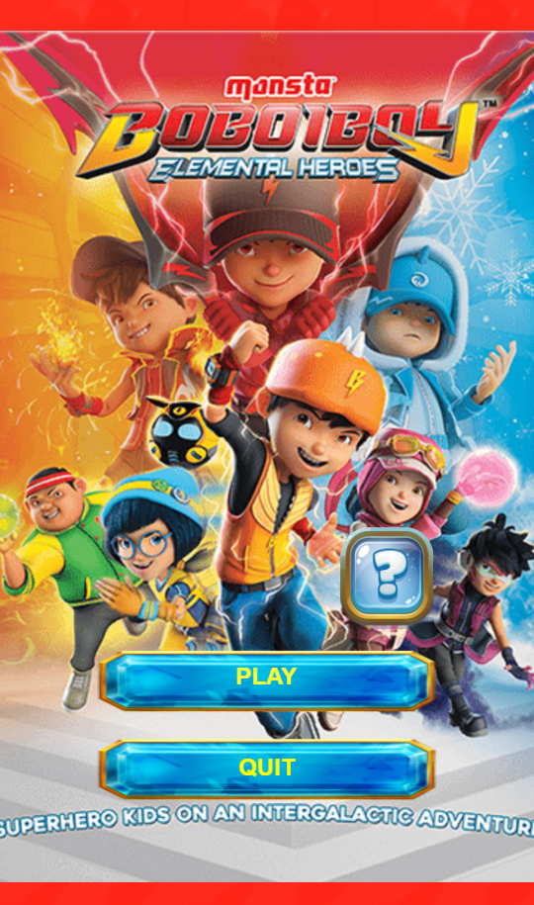

* + 1. Main Menu

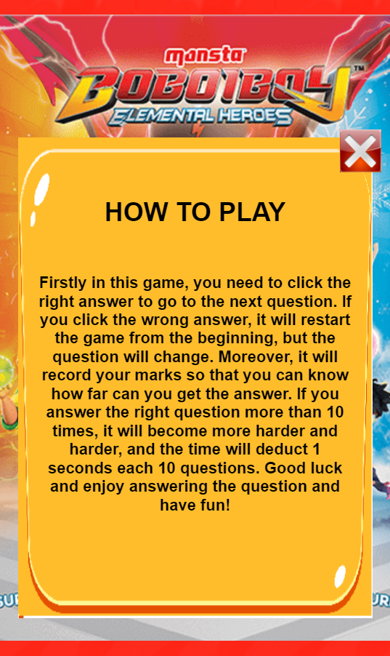

* + - 1. Manual Information

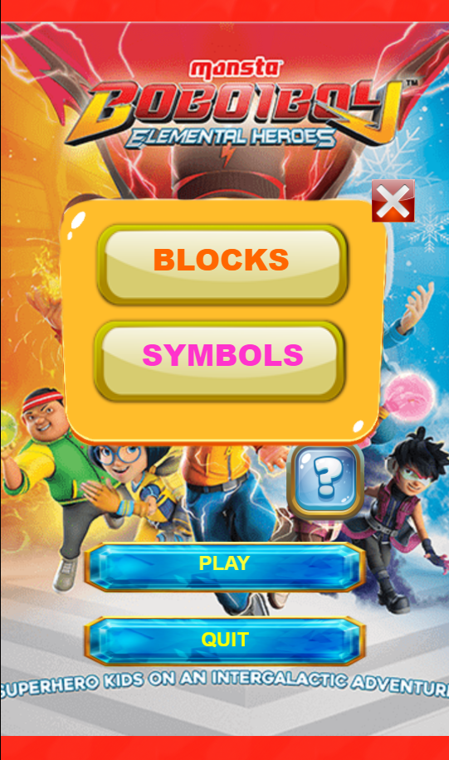

* + - 1. Blocks Button and Symbols Button

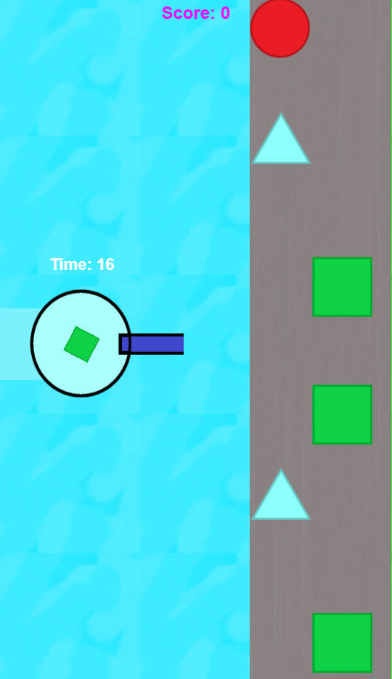

* + 1. Blocks Gameplay

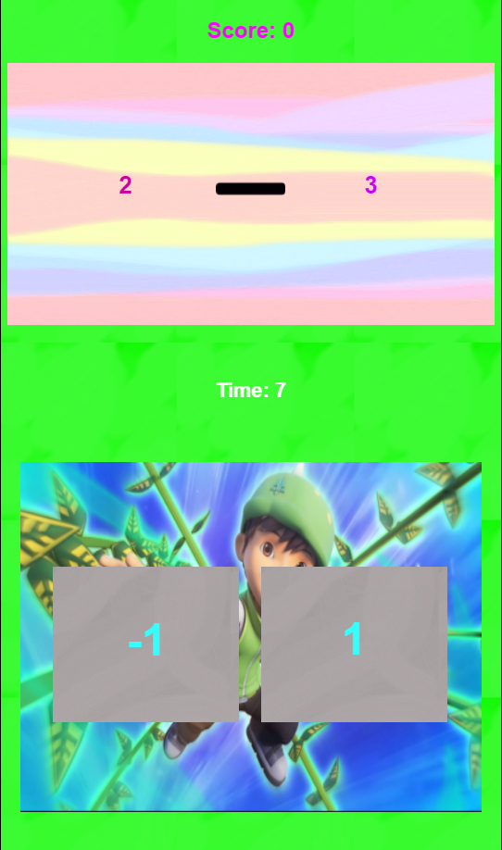

* + 1. Symbols Gameplay

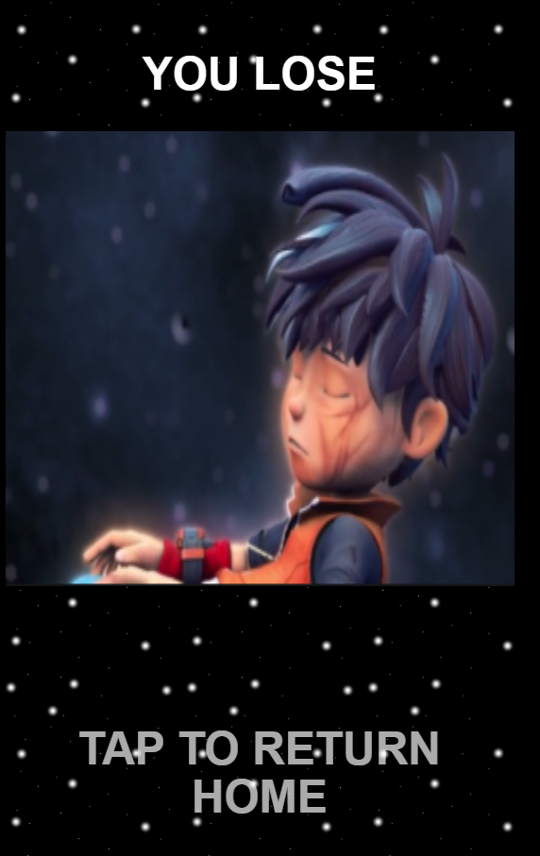

* + 1. Game Over

1. **USER MANUAL (step of using apps)**

HOW TO PLAY MATHEMATIC FOR KIDS

**MAIN MENU PAGE**

* In the main menu, there will be a start button to play the game. User need to press the start button to proceed to the game section.
* For the user who are not experience with the game, they can press the “Question Mark” button that indicates the manual information of the game.
* User can quit the game by pressing the quit button



Quit/Close Button

t Button

Manual Information Button

Close Button

Play Button

Manual Information Button

**MANUAL INFORMATION PAGE**

* If the user pressed the manual information button, the game automatically brings the user to the page where the game explains about how it works. Click the close button if the player already read it



Close Button

* As the user pressed the play button, the game will pop up 2 more button whether the player want to play on Blocks Page or Symbols Page and as usual if the player want to close it, just click the close button



Symbols Button

Blocks Button

Close Button

**PLAY BLOCKS GAME**

* If the player click the Blocks Button, then it will go to Blocks Page and show the shooter blocks and all different blocks on right side.
* The score and timer will show too so that the player know what score there have reach and how long the time to shoot the blocks
* If user cant destroy the blocks in time, it will automatically proceeds to the game over page

Score



Blocks

Block Shooter

Timer

**PLAY SYMBOLS GAME**

* If the player click the symbols button, it will start to go to Symbols page.
* On Symbols Page, it will show score, problem that need to be solve, timer and two buttons that some of them have the right answer.
* If user cant destroy the blocks in time, it will automatically proceeds to the game over page

Score



Timer

Board

Answer 1

Answer 2

**GAME OVER PAGE**

* After the player cant solve the problem with the time that have been given whether the player is playing Blocks or Symbols, it will automatically ends by proceeding to the game over page.
* If the player want to return home or play again, just click anywhere to return to menu page.



Return Home Button

1. **PROJECT GITHUB LINK**